Arrays in MongoDB-Array Modifiers
Insert the following documents to a collection named “movies”
[
{
title: "Inception",
genres: ["Sci-Fi", "Action"],
ratings: [4, 5, 5],
cast: ["Leonardo DiCaprio", "Joseph Gordon-Levitt"]
},
{
title: "Interstellar",
genres: ["Sci-Fi", "Drama"],
ratings: [5, 5, 4],
cast: ["Matthew McConaughey", "Anne Hathaway"]
}
]
Assignment Questions:
- Add a new genre "Thriller" to the movie Inception.
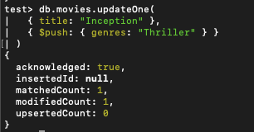
- Add cast member "Elliot Page" to Inception ensuring no duplicates.
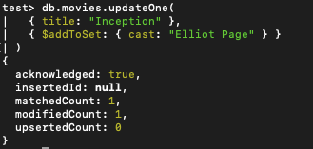
- Add multiple ratings 3, 4, and 5 to Interstellar in a single operation.
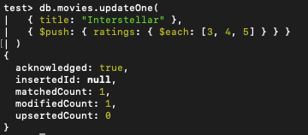
- Insert cast member "Hans Zimmer" at the first position of the cast array for Interstellar.
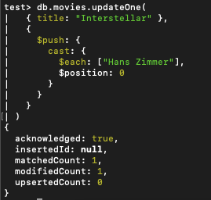
- Remove the last rating from Interstellar.
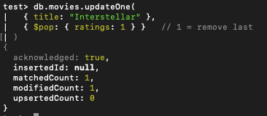
- Remove the first cast member from Inception.
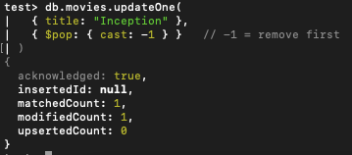
- Remove genre "Drama" from all movies.
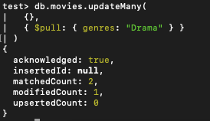
- Remove genres "Sci-Fi" and "Action" from Inception using a single query.
